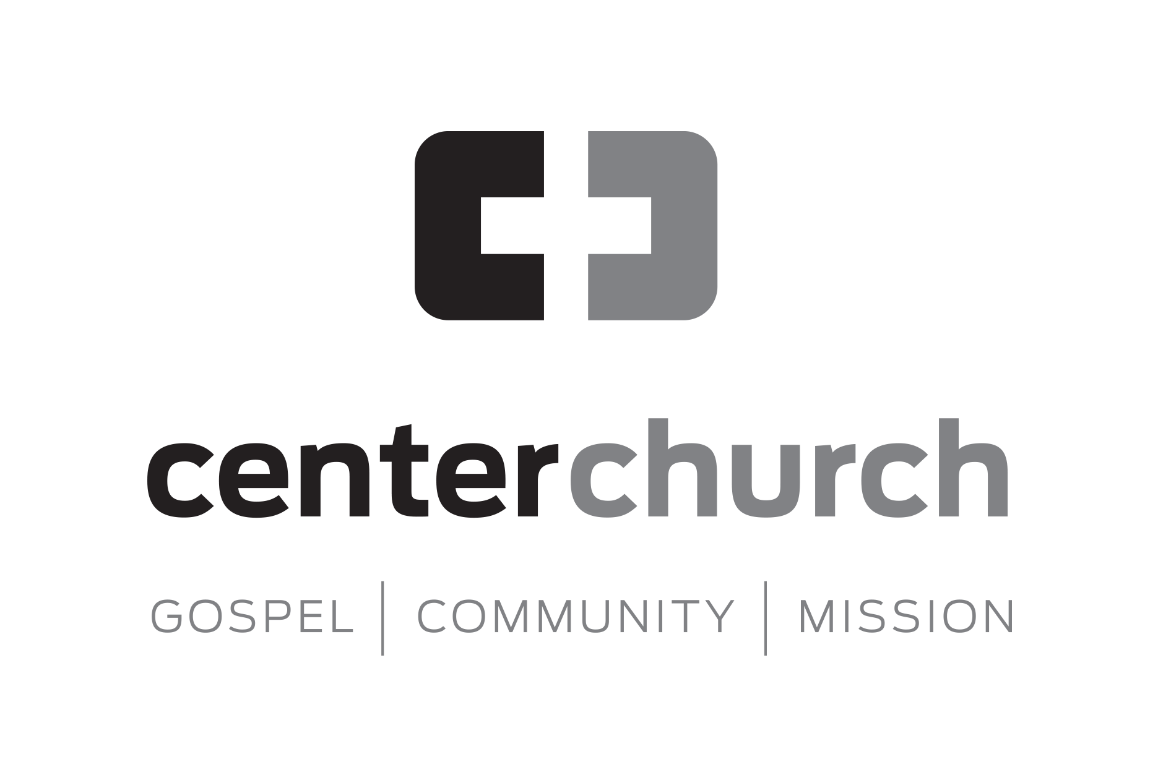
WORSHIP LEADER

HOURS: Part Time/Hourly/Non-exempt (appx. 8 hours per week)

DESCRIPTION: The Worship Leader will be responsible for cultivating a Gospel-centered culture within Center Church through the leadership and development of the music ministry.

OBJECTIVE: To remind the church through the medium of music of the greatness of Jesus, as well as helping the church utilize their musical gifts in an effort to build up the broader church.

QUALIFICATIONS AND SKILLS
- Affirm and embody the vision and core values of Center Church
- Proficiency in and ability to lead music both instrumentally and vocally
- Ability to anticipate needs and issues and proactively provide effective solutions
- Strong administrative skill, work independently, manage time well, and attention to detail
- Must pass a criminal record background check

RESPONSIBILITIES
SUNDAY MORNING WORSHIP SERVICE:
- Plan musical elements (i.e. choosing songs), coordinate with volunteer musicians, and lead the musical elements of the Sunday morning worship service.
- Maintain and develop a database of gospel-centered music to be utilized in music ministry.
- Develop volunteer musicians and lead the worship team to build unity amongst members.
- Work closely with Lead Pastor to create a coordinated, cohesive, gospel-centered worship service weekly.

SPECIAL EVENTS:
- Creatively plan for and lead musical elements for special events and holidays, as necessary.

OTHER:
- Continually evaluate effectiveness of current worship-related systems (e.g. Planning Center Online) and processes (i.e. music database, volunteer coordination) and propose and implement creative solutions where appropriate.
- Complete other tasks as directed by Lead Pastor.
- Handle communication and scheduling as well as facilitate other support and coverage as needed when unable to lead personally.
- Attend Center Church staff meetings.

COMPENSATION AND BENEFITS: Semi-monthly compensation; not eligible for benefits.

